Superficial perineal pouch

Location
Superficial to perineal membrane
Stretches across the pubic arch

Boundaries
Superficial: Colles’ fascia.
Deep: perineal membrane.
On each side: ischiopubic rami.
Posteriorly: closed by the fusion of perineal membrane with colles’ fascia.
Anteriorly: open & continuous with the spaces of scrotum, penis & anterior abdominal wall.
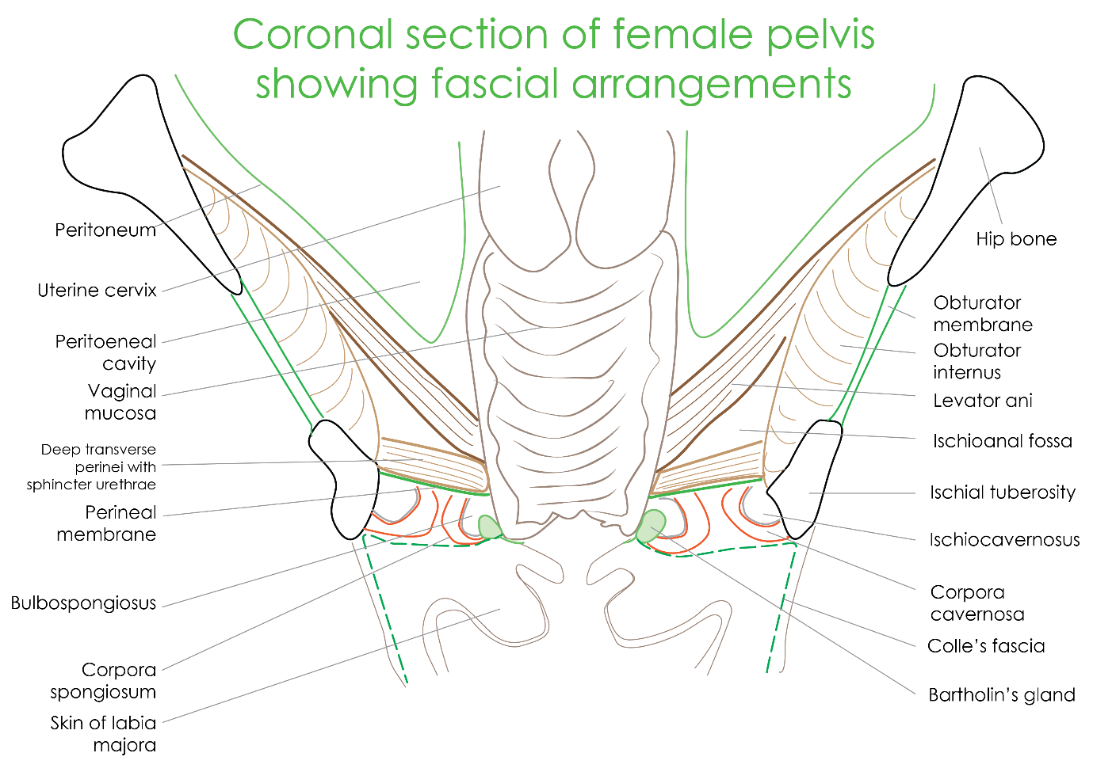

Contents of superficial perineal pouch
Root of the penis made up of 2 corpora cavernosa & 1 corpus spongiosum (traversed by urethra).
Body of clitoris made up of 2 corpora cavernosa.
2 bulbs of vestibule, 1 on each side of vaginal orifice unite near glans clitoris.

Muscles in the superficial perineal pouch
Ischiocavernosus covering the corpora cavernosa of penis/clitoris.
Bulbospongiosus covering the corpus spongiosum/bulb of the vestibule.
Superficial transversus perenei.

Superficial pouch – vessels
2 branches of perineal artery-
- Posterior scrotal/labial arteries.
- Transverse perineal arteries.
4 branches from the artery of penis-
- Artery to the bulb of penis/clitoris.
- Urethral artery.
- Dorsal artery of penis.
- Deep artery of penis.

Superficial pouch – nerves
3 branches from the perineal nerve
- Posterior scrotal / labial n.
- Branch to the bulb of penis/vestibule.
- Muscular branches.
Long perineal n. from posterior cutaneous nerve of thigh.

Superficial pouch - other contents
Male
- Spongy urethra
- Ducts of bulbourethral glands
Female
- Urethra
- Vagina
- Greater vestibular glands

Greater vestibular / bartholin’s glands
- Pea shaped mucous glands.
- Lie posterior to the bulb of vestibule.
- Homologuous of bulbourethral glands in men.
- Ducts open into the vestibule of perineum along the posterolateral margins of vaginal opening.
- Its secretions lubricate the vagina during intercourse.
